SET-1
1. Draw Flow chart using RAPTOR, write algorithm and Implement using C program to read two numbers from user and calculate addition, subtraction multiplication and division of those numbers.
FLOWCHART:
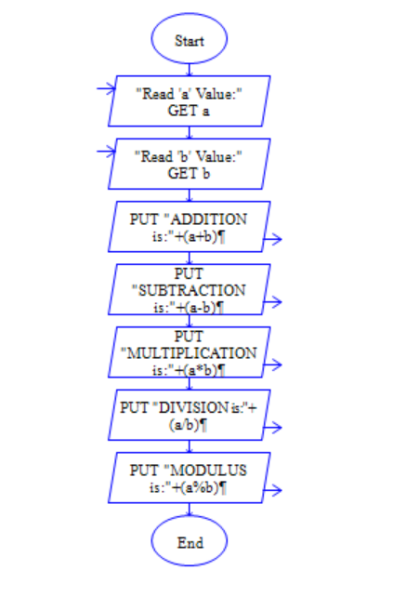
C Program:
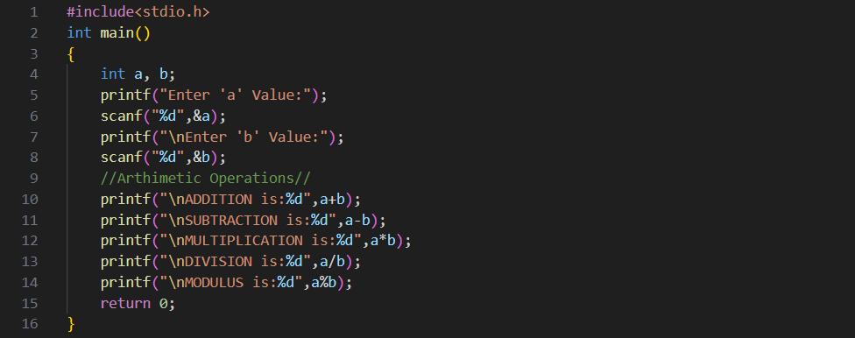

2. Draw Flow chart using RAPTOR, write algorithm and Implement using C program that checks the given number is Palindrome or not.
FLOWCHART:
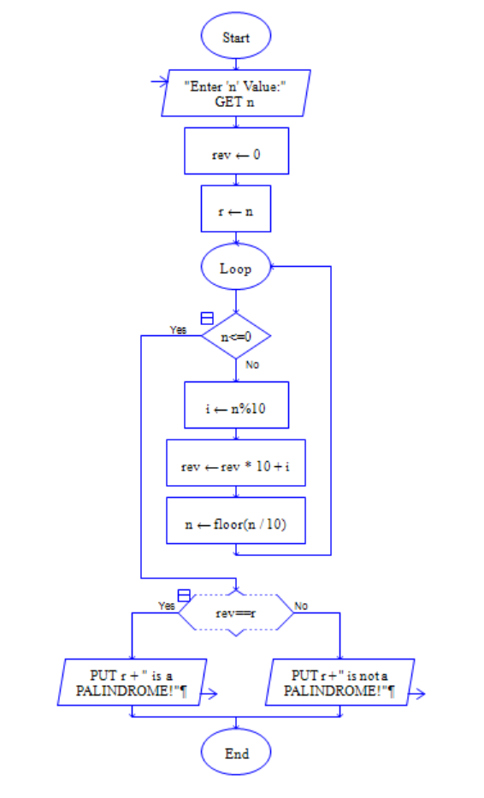
C-Program:
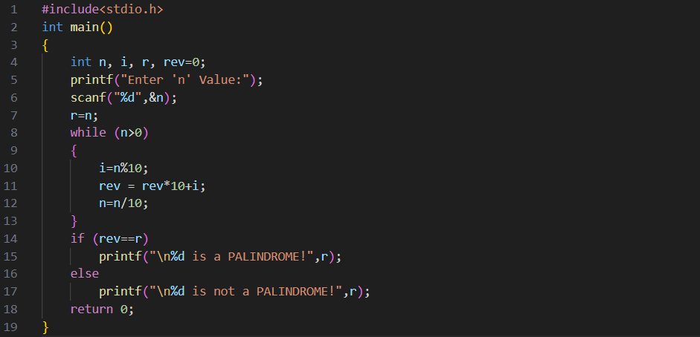

3. Define keyword, constant and variable.
Ans. Keyword
A keyword is a reserved word in a programming language that has a specific function and meaning. You can't use keywords as names for variables, functions, or other identifiers. Examples in C include int, return, and if.

Constant
A constant is a value that doesn’t change during the execution of a program. It’s a fixed value assigned at compile-time. For example, in C, you can define a constant like this:
Here, MAX is a constant with a fixed value of 100.

Variable
A variable is a named storage location in memory that can hold different values during the execution of a program. For example:
Here, count is a variable that can be updated as needed throughout the program.

4. Write and explain syntax of ―for‖ loop.
Ans. The for loop is a control flow statement that allows code to be executed repeatedly based on a condition.
SYNTAX: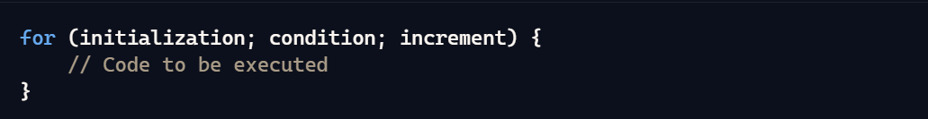

Explanation:
- Initialization: This step initializes the loop control variable and is executed only once at the beginning.
  - Example: int i = 0;
- Condition: This is the condition that must be true for the loop to continue executing. The loop runs as long as this condition is true.
  - Example: i < 10;
- Increment: This updates the loop control variable after each iteration.
  - Example: i++

Example Code:
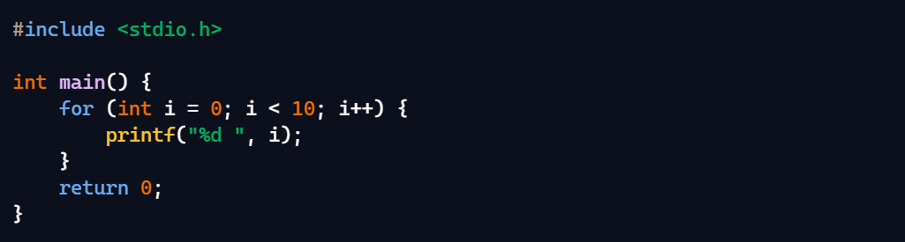
How It Works:
- Initialization: int i = 0; sets up the loop control variable i.
- Condition: i < 10; checks if i is less than 10.
- Increment: i++ increases i by 1 after each loop iteration.
In this example, the loop prints numbers from 0 to 9. Once i reaches 10, the condition i < 10 is false, and the loop exits.

SET-2
1.Draw Flow chart using RAPTOR, write algorithm and Implement using C program to calculate the value of Y from the equation y = x² + 2x + 3 (read the value of X from user) and calculate the area of a Circle.
Ans. C-Program:
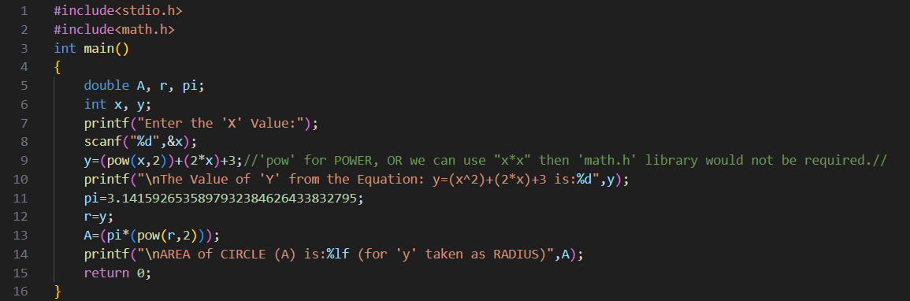
FLOWCHART:
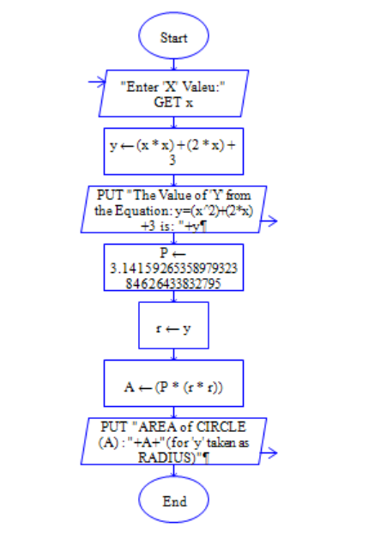

2. Draw Flow chart using RAPTOR, write algorithm and Implement using C program that checks the given number is prime or not.
Ans.
C-Program:
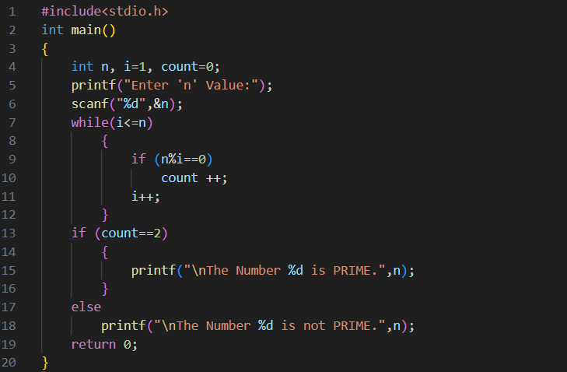
FLOWCHART:
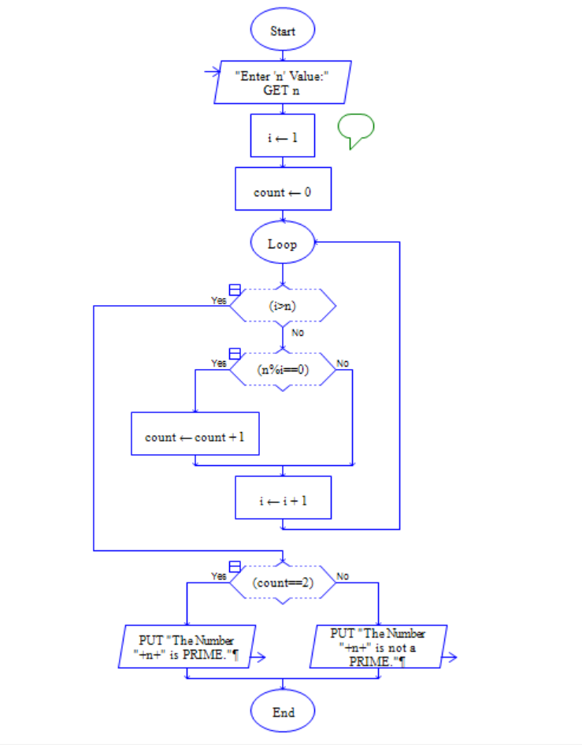
3. What is format specifier?
Ans. A format specifier is a placeholder used in functions like printf and scanf in C to define how data should be formatted. It tells the function the type of data to expect and how to display or read it. Here are some common format specifiers:
- %d: Integer (decimal)
- %f: Floating-point number
- %lf: Double precision floating-point number
- %c: Single character
- %s: String (null-terminated character array)
- %x: Hexadecimal integer
- %o: Octal integer
For example, in printf("Value: %d", x);, %d specifies that x should be printed as an integer.
Format specifiers help control how data is processed and displayed, making your output precise and readable.
4. Distinguish between while and do-while statements.
Ans. while LOOP:
SYNTAX:
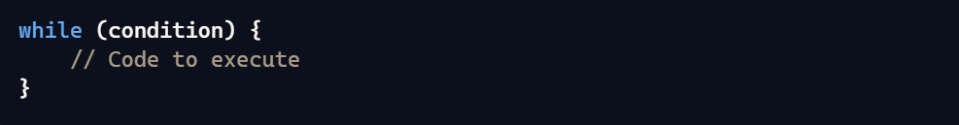
Condition Check: The condition is evaluated before entering the loop.
Execution: If the condition is false initially, the loop body might not execute at all.
Use Case: Ideal when you need to check the condition before executing the loop.
do-while LOOP:
SYNTAX:
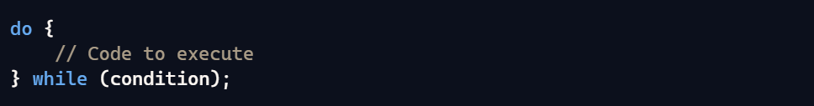
Condition Check: The condition is evaluated after executing the loop.
Execution: The loop body executes at least once, regardless of whether the condition is true or false initially.
Use Case: Ideal when you need the loop to execute at least once before checking the condition.

SET-3
1. Draw Flow chart using RAPTOR, write algorithm and Implement using C program increment, decrement operator and Assignment Operators.
C Program:
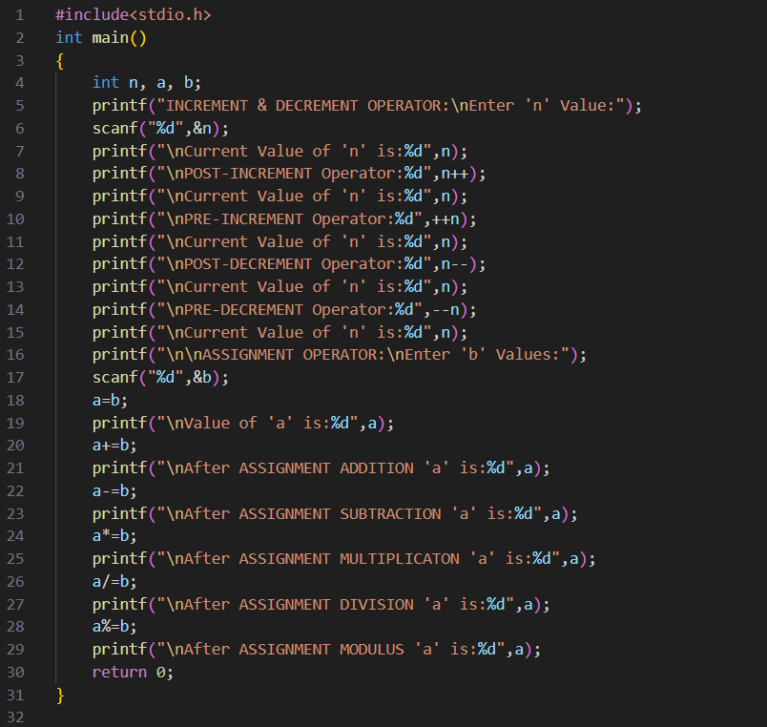
FLOWCHART:
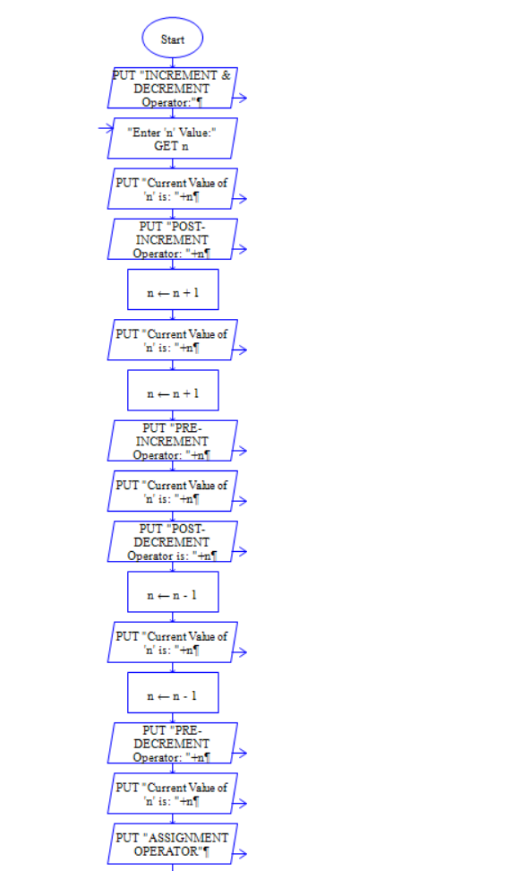
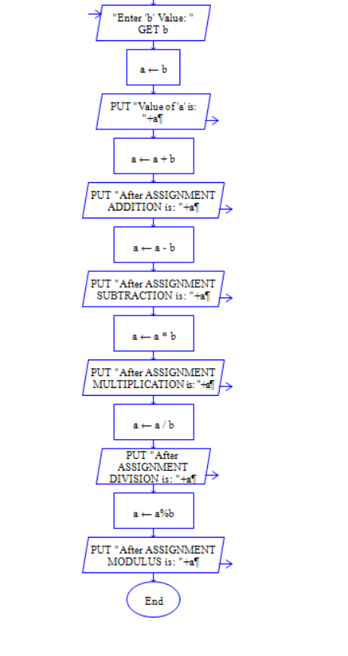
2. Draw Flow chart using RAPTOR, write algorithm and Implement using C program finds factorial of a given number.
Ans.
C Program:
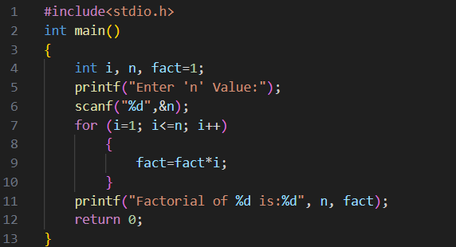

FLOWCHART:
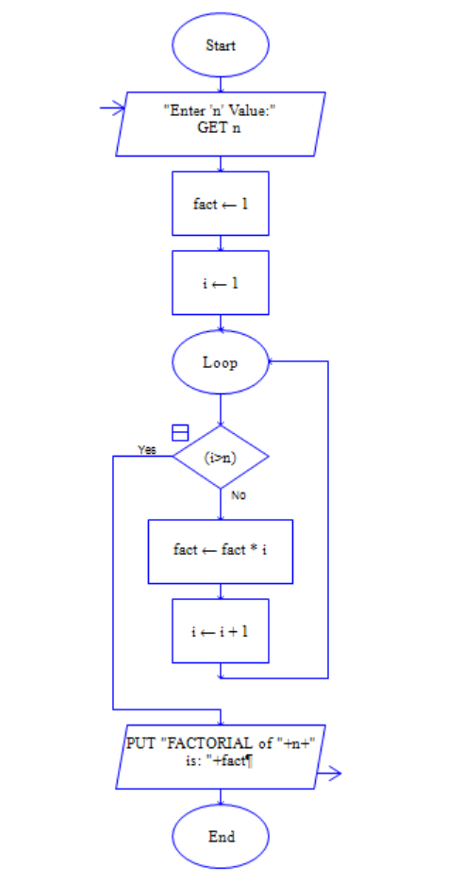
3. Write a short note on type casting.
Ans. Type Casting is the process of converting one data type into another. It’s particularly useful in programming when you need to perform operations on different data types or want to ensure compatibility. There are two main types of type casting:
1. Implicit Type Casting (Automatic)
- Description: Done automatically by the compiler without explicit instruction from the programmer.
- Example: Converting an int to a float when performing arithmetic operations. The compiler automatically converts into other Data Type.
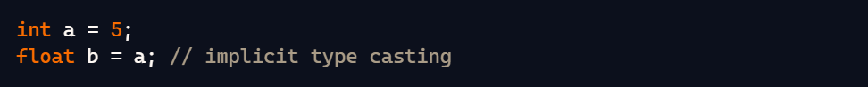
2. Explicit Type Casting (Manual)
- Description: Requires explicit instruction from the programmer to perform the conversion.
- Syntax: (data_type) expression
- Example: Converting a float to an int.
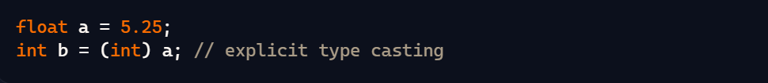

4. Differentiate between break and continue.
Ans. Differentiate between break and continue.
The break and continue statements are used to control the flow of loops in programming, but they serve different purposes.
- break Statement:
It immediately terminates the loop or switch statement and transfers control to the statement following the loop or switch. It is typically used to exit a loop when a certain condition is met, or to exit a switch case. Ends the loop entirely, skipping any remaining iterations.
- continue Statement:
It skips the current iteration of the loop and proceeds to the next iteration. It typically used to skip specific iterations based on a condition. It skips the remaining code inside the loop for the current iteration and moves to the next iteration.
NOTE:
- break ends the loop, whereas continue skips to the next iteration.
- break is often used to exit loops or switch statements prematurely.
- continue is used to skip the current loop iteration under certain conditions.
SET-4
1. Draw Flow chart using RAPTOR, write algorithm and Implement using C program conditional operator and bit wise operator.
C-Program:
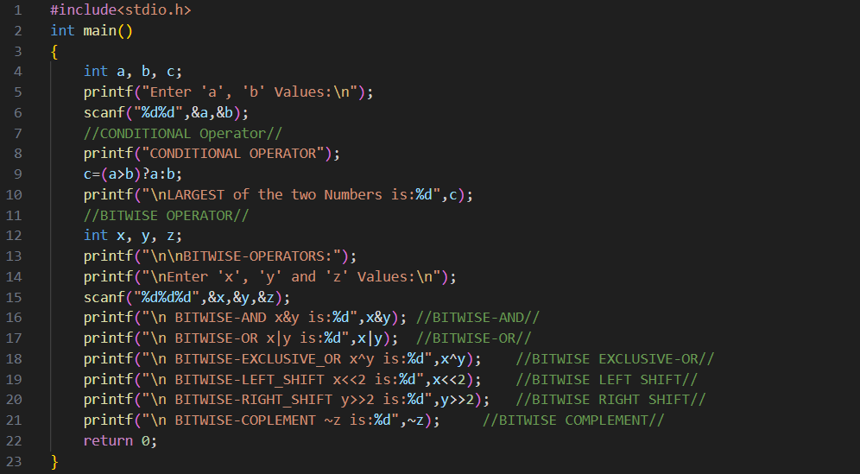
Flowchart:
NO IDEA

2. Draw Flow chart using RAPTOR, write algorithm and Implement using C program arithmetic calculator using switch-case.
Ans. C-Program:
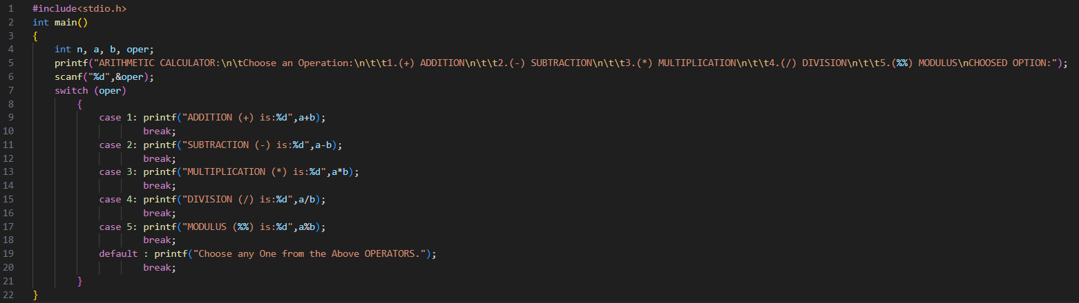
FLOWCHART:
NO IDEA

3. Define relational operator?
Ans. Relational operators are used to compare two values. The result of such comparisons is always a Boolean value, which means the result is either true or false.

4. Define goto with an example.
Ans. The goto statement is used in many programming languages to cause a jump to another point in the code. It's often discouraged in structured programming because it can lead to "spaghetti code," which is difficult to read and maintain. However, it can still be useful in certain situations, such as error handling or breaking out of deeply nested loops.
Examples:
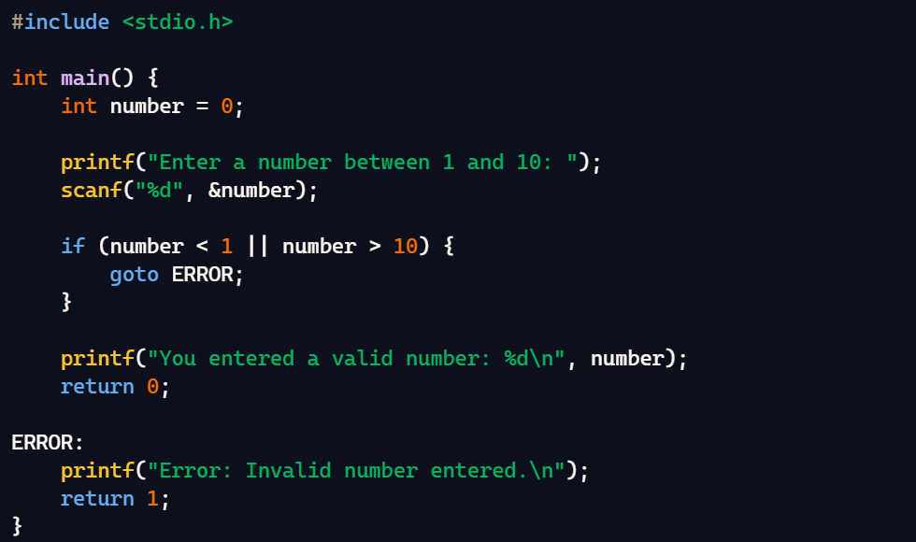
If the user enters a number outside the range of 1 to 10, the program jumps to the ERROR label and prints an error message. Otherwise, it continues executing the normal flow of the program.
SET-5
1. Draw Flow chart using RAPTOR, write algorithm and Implement using C program that finds the quadratic roots of an equation (real or imaginary).
Ans.
C-Program:
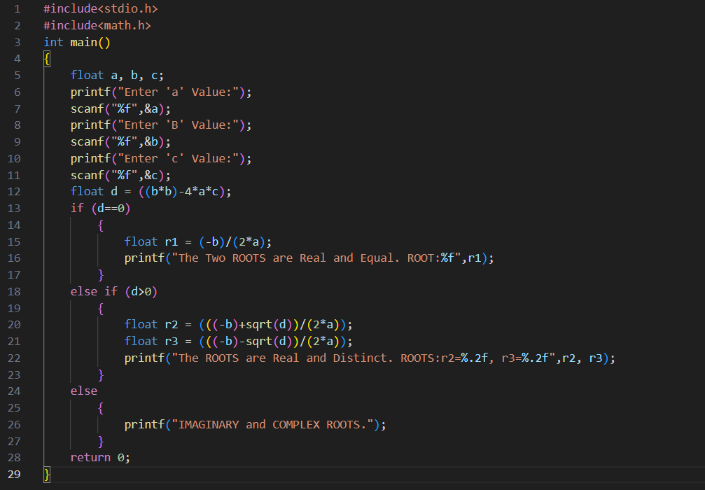
FLOWCHART:
NO TIME
2. Draw Flow chart using RAPTOR, write algorithm and Implement using C program that calculates sum of even numbers and odd numbers from 1 to n (n value supplied by the user).
Ans. C-Program:
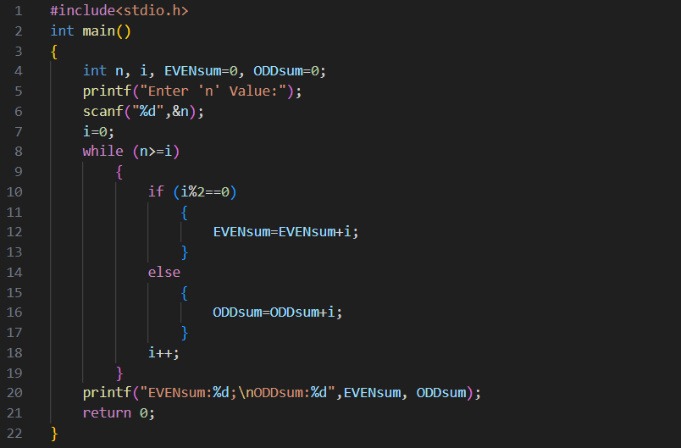

3. What is the purpose of adding comments in a program?
Ans. Adding comments in a C program enhances readability by explaining the code's purpose, making it easier to understand. They also provide valuable documentation for future maintenance and collaboration among developers. Additionally, comments can be used for debugging by temporarily disabling code sections without deleting them.
4. Write the syntax for nested if and else-if ladder?
Ans. Nested IF:
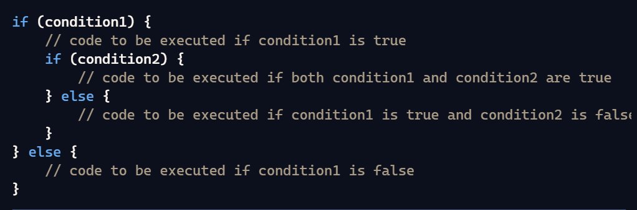

Else-if Ladder:
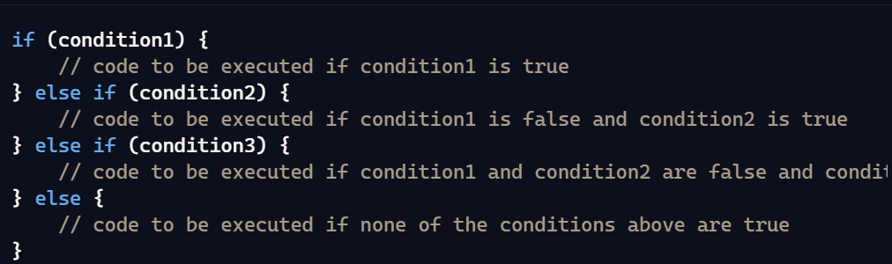

SET-6
1. Draw Flow chart using RAPTOR tool, write algorithm and Implement using C program to check whether the given number is Positive or Negative.
Ans. C-PROGRAM:
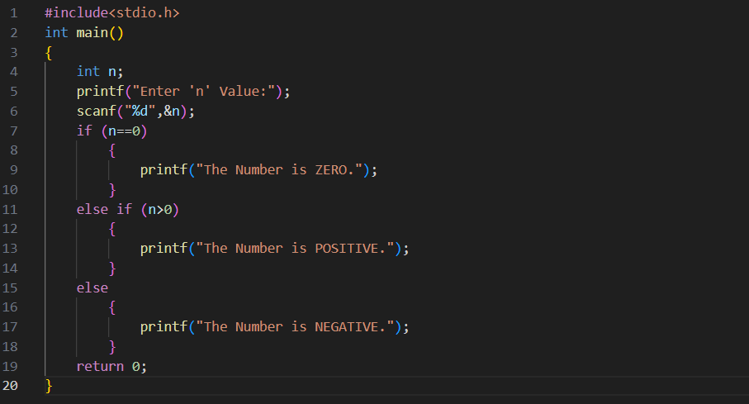

2. Draw Flow chart using RAPTOR, write algorithm and Implement using C program that finds sum of n natural numbers.
Ans. C-Program:
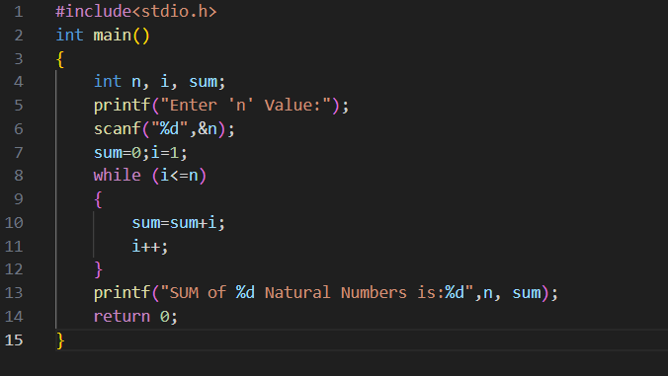
3. What is operator? Types of operators.
Ans. An operator in programming is a symbol that performs a specific operation on one or more operands. These operations can manipulate data values to produce a result. Here's a brief overview of common types of operators in programming:
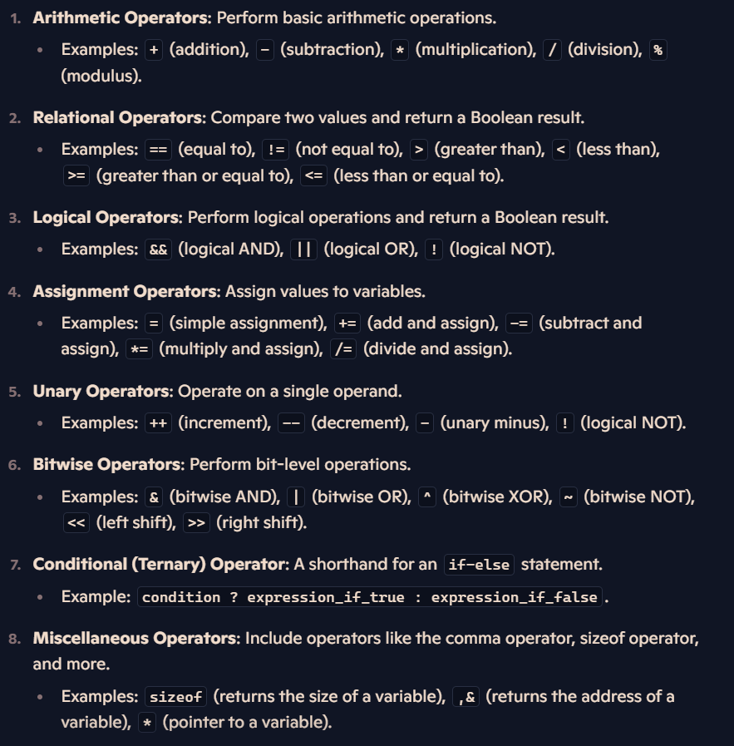

4. Classify the different types of decision making statements.
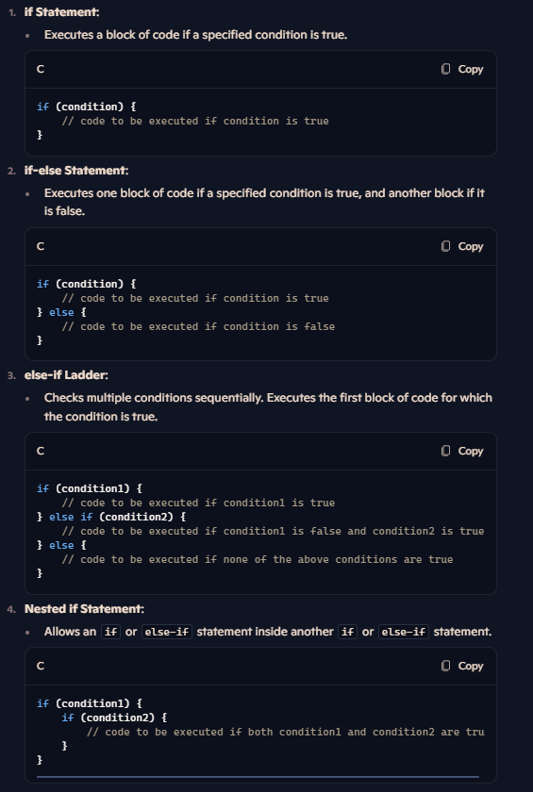
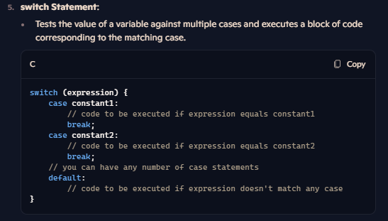
SET-7
1. Draw Flow chart using RAPTOR tool, write algorithm and Implement using C program to calculate the Largest of two numbers.
Ans. C-PROGRAM:
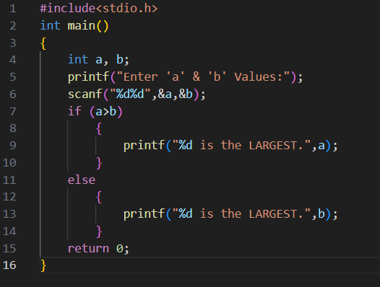
2. Draw Flow chart using RAPTOR, write algorithm and Implement using C program print n natural numbers.
Ans. C-PROGRAM:
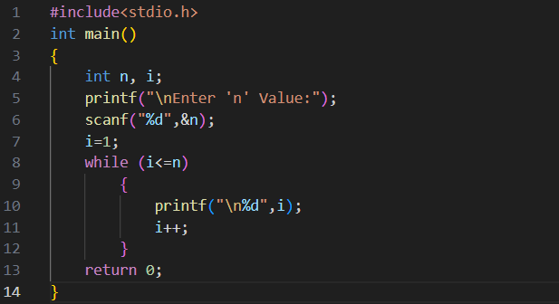

3. Explain special operators.
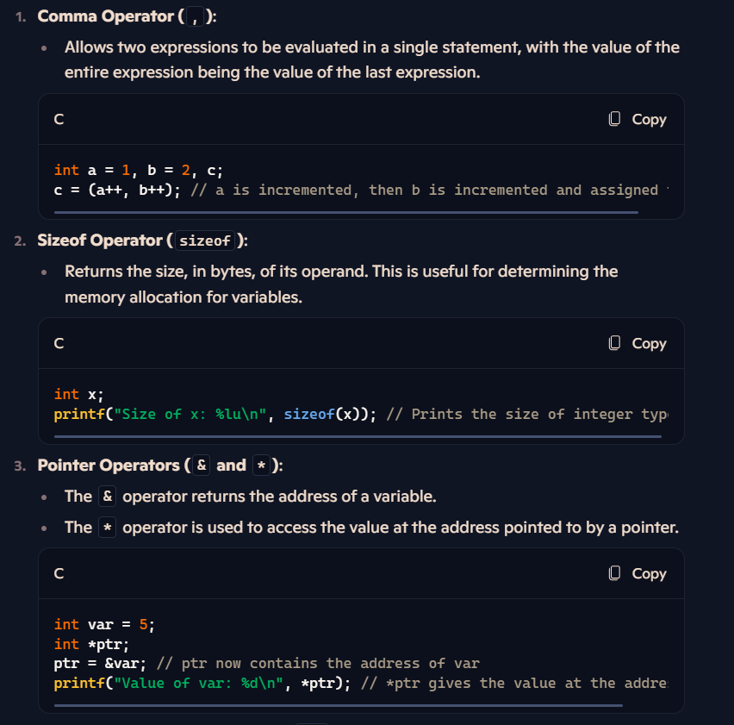
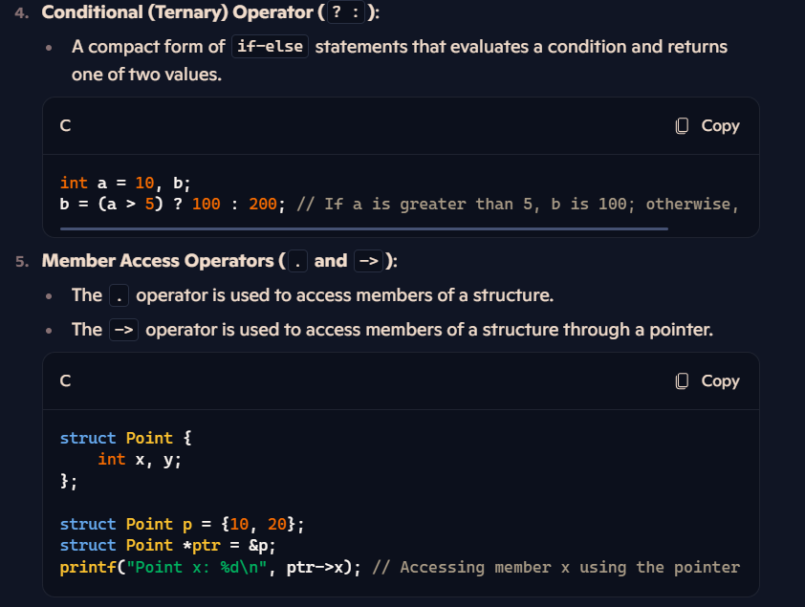
4. Difference between entry control and exit control loop.
Ans. 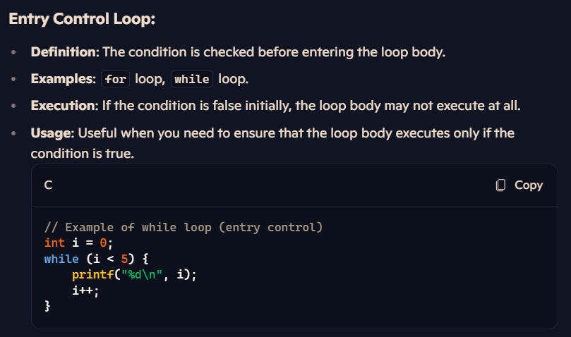
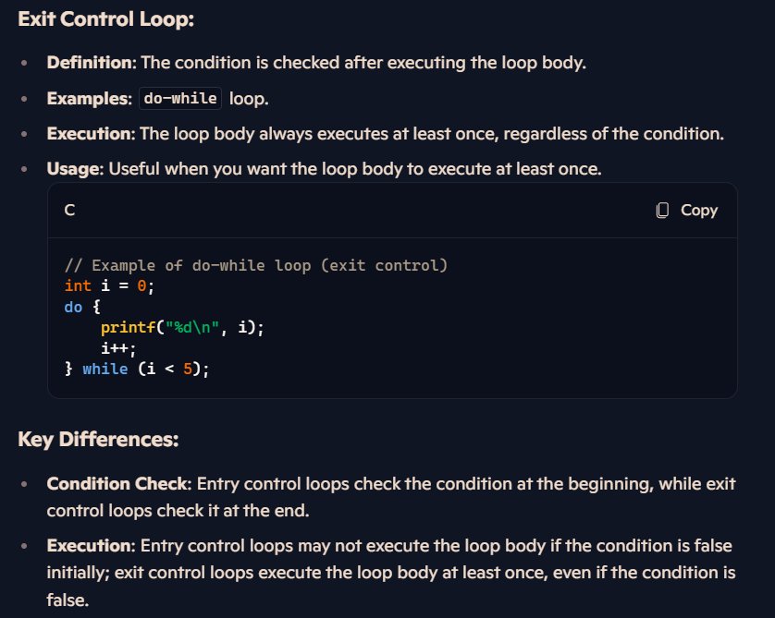

SET-8
1. Draw Flow chart using RAPTOR tool, write algorithm and Implement using C program to check whether the given number is even or odd.
Ans. C-PROGRAM:
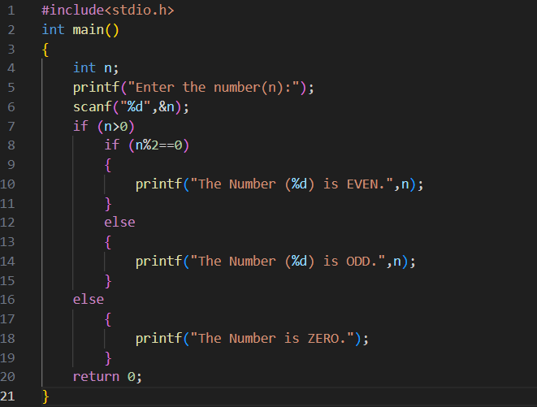
2. Draw Flow chart using RAPTOR, write algorithm and Implement using C program finds factorial of a given number.
Ans. C-PROGRAM:
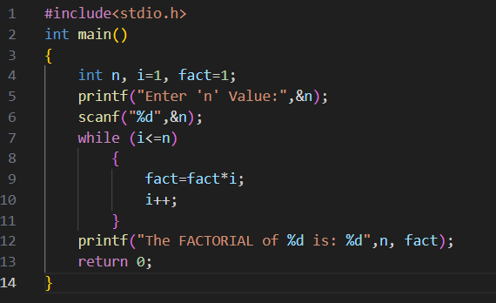
3. Write difference between algorithm and flowchart.
Ans.
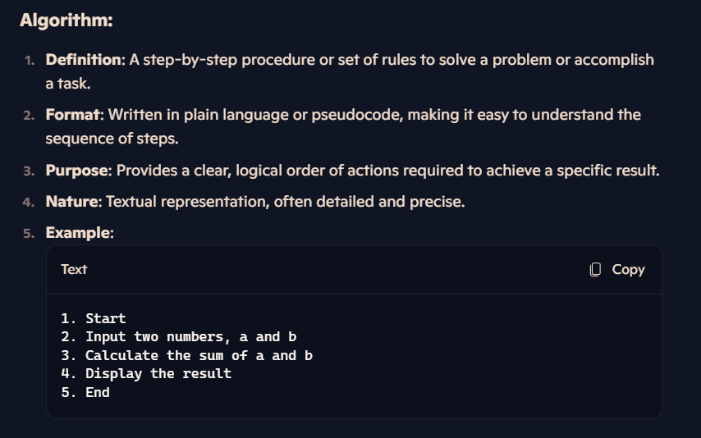
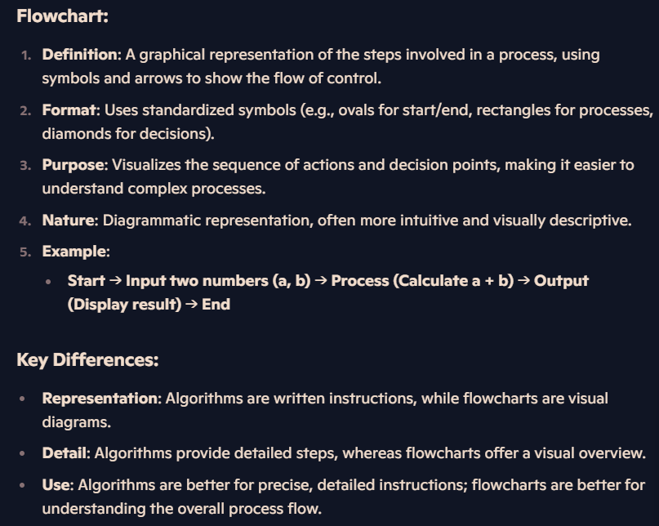
4. How switch case works without break statement.
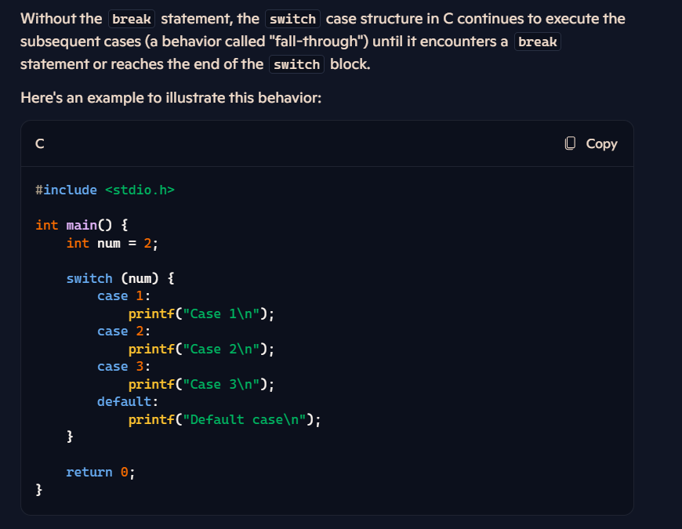
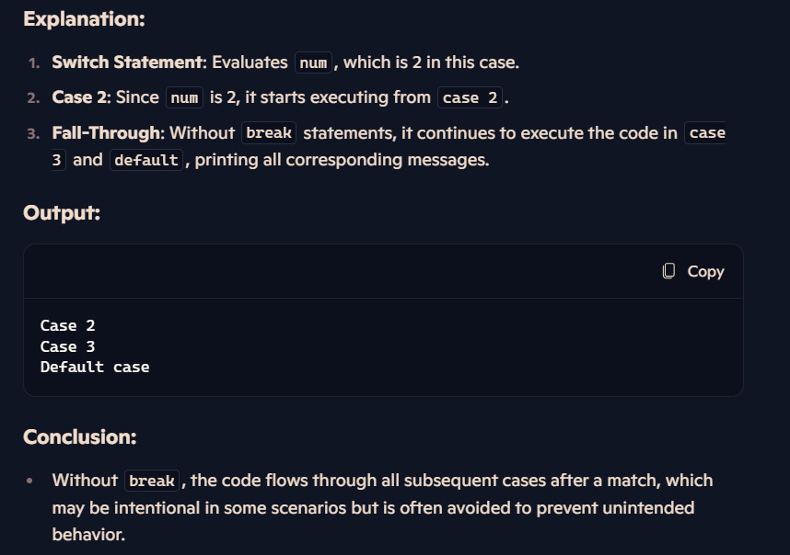

SET-9
1.Draw Flow chart using RAPTOR tool, write algorithm and Implement using C program to Check the given year is leap year or not.
Ans. C-PROGRAM:
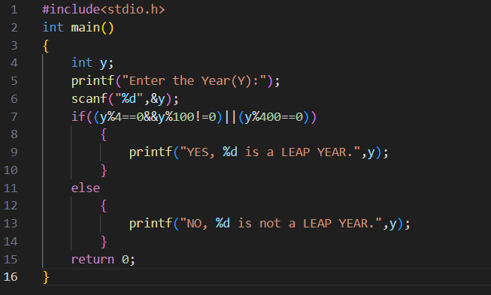

2. Draw Flow chart using RAPTOR, write algorithm and Implement using C program that finds sum of n natural numbers.
Ans. C-PROGRAM:
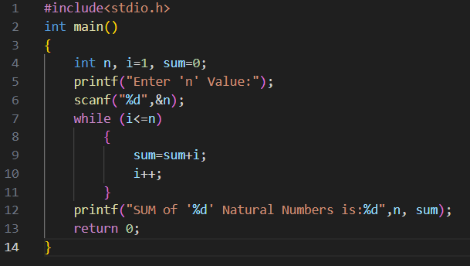
3. Explain different types of compilers.
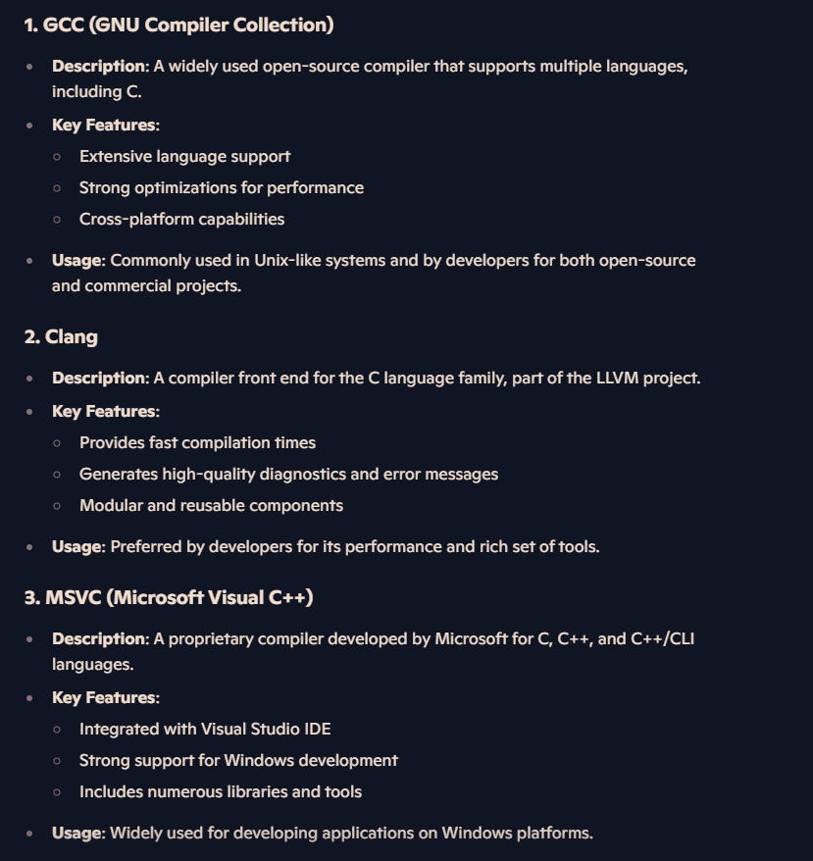
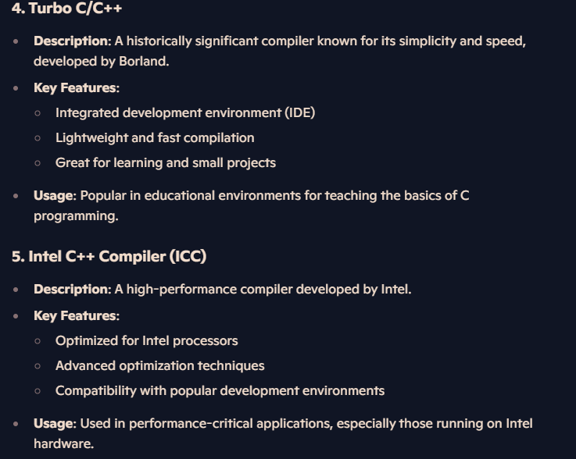

4. Write and explain syntax of ―for‖ loop.
Ans. The for loop in C is used to execute a block of code a specific number of times. It provides a concise way to iterate over a range of values.
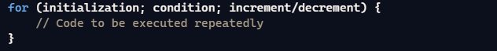
Initialization: This step is executed only once at the beginning of the loop. It's used to initialize the loop control variable(s).
Condition: The loop continues as long as this condition is true. It is evaluated before each iteration of the loop. If the condition is false, the loop terminates.
Increment/Decrement: This step is executed at the end of each iteration. It updates the loop control variable.
SET-10
1.Draw Flow chart using RAPTOR tool, write algorithm and Implement using C program to Calculate and display the grade of a student
i. < 30 % - Fail ii. Between 31 and 50 – C grade
iii. Between 51 to 60 – B grade iv. Between 61 to 75 – A grade
v. Greater than 75 – distinction
Ans. C-PROGRAM:
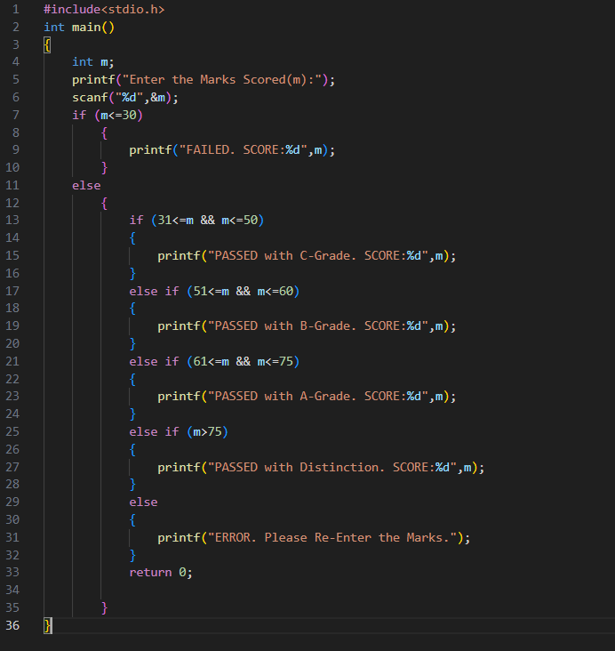
2.Draw Flow chart using RAPTOR, write algorithm and Implement using C program that checks the given number is prime or not.
Ans. C-PROGRAM:
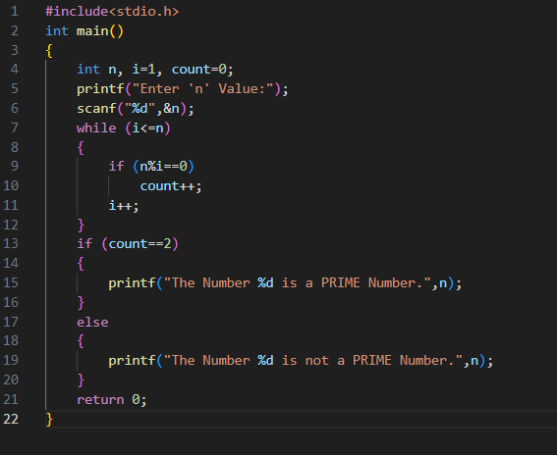

3. What is operator? Types of operators.
Ans.
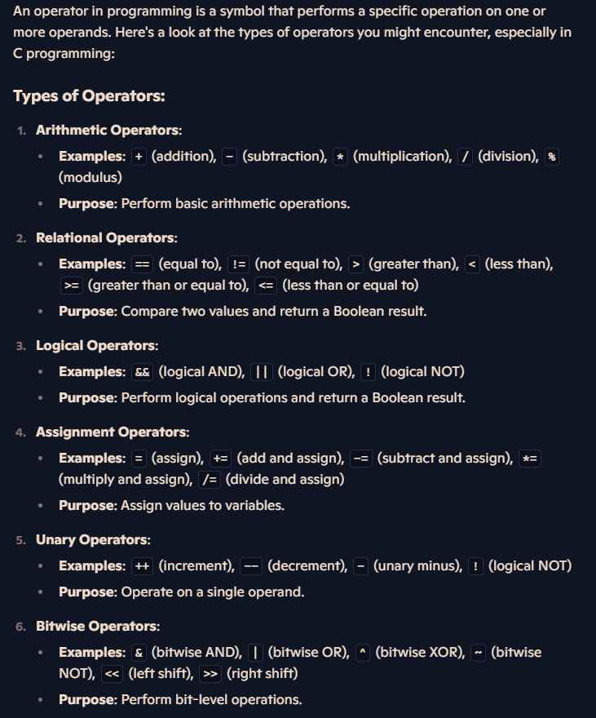
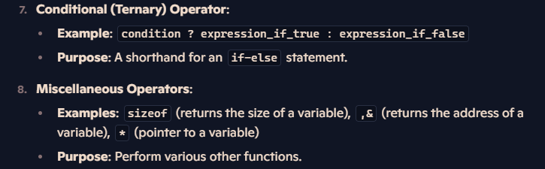

4. Distinguish between while and do-while statements.
Ans.
